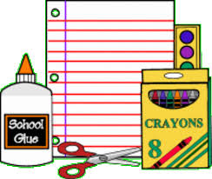 Mrs. Ruyffelaert
2015-2016
Suggested List of Supplies
Hello students and families!
I hope you are all excited to join my class! I know I am looking forward to meeting all of you! Hopefully you will have a fun and relaxing summer. I can’t wait to hear what you have to share!
If you are planning on buying school supplies over the summer, here is a suggested list of items. We will be working on organizational skills this year and these things will help you along.
If possible, please bring the following on the first day of school:

- 1 package of pencils
- 1 package of expo markers
- 2 red pens
- 1 Glue Stick
- 1 pair of scissors
- 1 package of colored pencils or crayons
- A zippered pencil case or a gallon sized zip-locked bag to keep all your items in one place in your desk (Please do not bring a plastic pencil box-they take up too much space in your desk.)
- 8 colored pocket folders of various colors
- A 1 inch binder
- 5 notebooks (hard covered marble composition books fit best in desk or folder, but any will do)
- 2 highlighters
- 1 package of sticky notes
- 1 package of 3x5 index cards
- Community Supplies
  - Tissues
  - Paper Towels
  - 409 or cleaning spray
  - Pencils
  - Plastic Baggies
  - Hand sanitizer
  - Expo Markers
  - Cleaning Wipes

I am looking forward to meeting you at our “Meet and Greet,” which will take place on Thursday, August 28 from 6:00-7:00 p.m.

Mrs. Ruyffelaert

