The Engineering Design Process

<http://www.eie.org/overview/engineering-design-process>

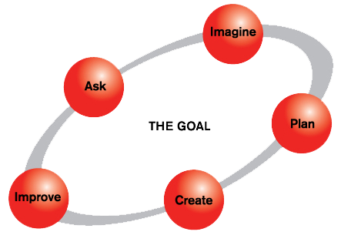

**ASK:**What is the problem? How have others approached it? What are your constraints? What do we want to accomplish? What are the project requirements? What are the limitations? What is our goal? Gather information and conduct research - talking to people from many different backgrounds.

**IMAGINE:**What are some solutions? Imagine and brainstorm ideas. Be creative; build upon the wild and crazy ideas of others. Investigate existing technologies and methods to use. Explore, compare and analyze many possible solutions. Choose the best one.

**PLAN:**Based on the needs identified, select the most promising idea. How will it work? What materials and tools are needed? How will you test it to make sure it works? Draw a diagram. Make lists of materials you will need.

**CREATE:** Assign team tasks. Follow your plan and create something. Build a prototype and test it against your design objectives. Push yourself for creativity, imagination and excellence in design. Analyze and talk about what works, what doesn't and what could be improved. Does it work? Test it out!

**IMPROVE:**What works? What doesn't? What could work better? Discuss how you could improve your product. Make revisions. Draw new designs. Fine-tune your design to make your product the best it can be.

It’s important to note that the EDP is flexible. There are as many variations of the model as there are engineers. Engineers often work on just one or two steps, and then pass their work to another team.

 Also note that the EDP is a cycle – there’s no official starting point or ending point. You can begin at any step, focus on just one step, move back and forth between steps, or repeat the cycle. For example, after you improve your design once, you may want to begin all over again, to refine your technology. You can use the EDP again and again!