**HOLIDAY SPIRIT WEEK!**

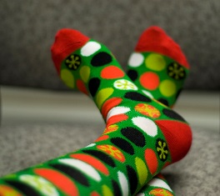

**Monday**: Holiday socks

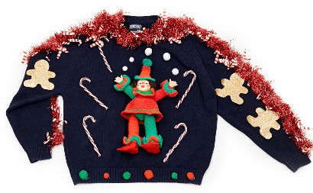

**Tuesday:** Ugly holiday sweaters

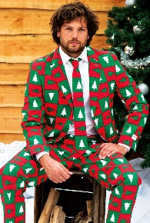

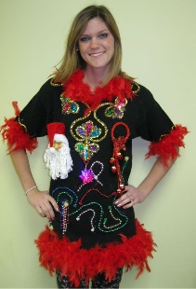

**Wednesday:** Wacky Holiday Clothes



**Thursday:** Holiday twinning

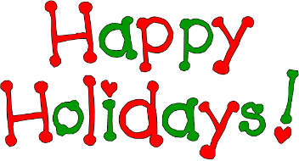

**Friday:** Holiday colors