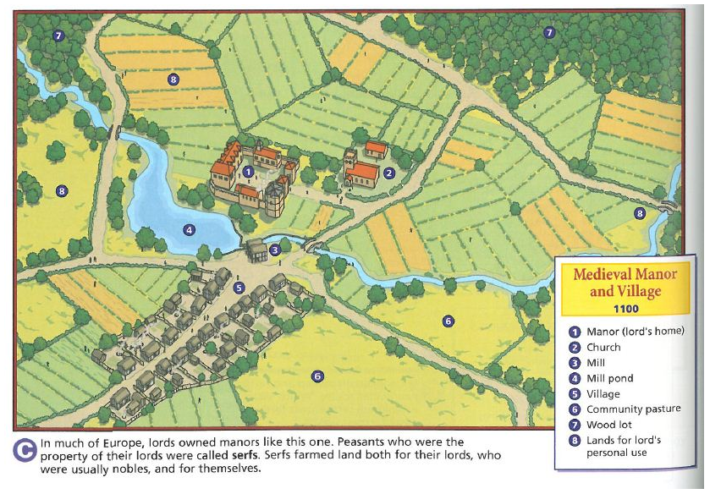

**Directions: On a piece of white paper, design your own manor and village using this as an example. Color your drawing.**